### INTRODUCTION

### 1.2 Overview

### Implementing CRM for Result tracking of a candidate with internal marks.

This application gives the result of an internal marks for each semester or for the final schools results. It can be generate or modified with proper certificates or mark statement provided in the schools or colleges. It is a type of a record in an application which contains all the candidates internal marks. It is useful in all over the world in education level places such as schools, colleges, offices,etc,. A candidate can easily identify that his\her own internal marks by tracking using CRM.

### 1.3 Purpose

* We can track the internal results of the students.
* Highly useful application for the students or a candidate.
* Every data as marks entered in the application is verified by students or candidates.
* Details are kept in a safety manner.
* No one cannot be operate another candidate personal mark statement.
* High amount of the information is stored in the application of an individual

### 2 Problem Definition & Design Thinking

### 2.1 Empathy Map

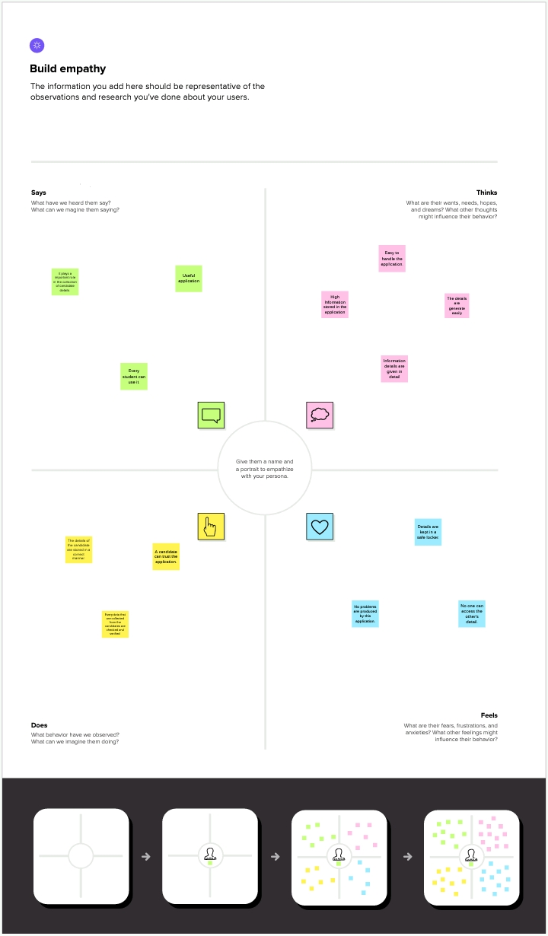

### 2.2 Ideation & Brainstorming Map

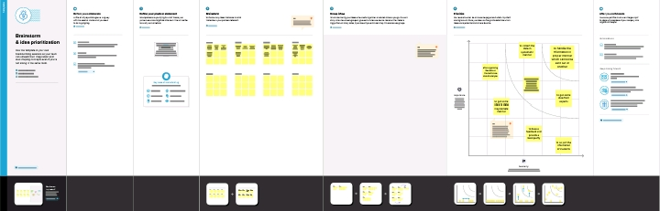

### 3 Result

### 3.1 Data Model

|  |  |
| --- | --- |
| Object Name | Fields in the Objects |
| 1.Semester | |  |  | | --- | --- | | Field Label | Data Type | | Semester Name | Text | | Course | Lookup | |

|  |  |
| --- | --- |
| Object Name | Fields in the Objects |
| 2. Candidate | |  |  | | --- | --- | | Field Label | Data Type | | Candidate Name | Text | | Candidate ID | Number | | Semester Name | Text | | Internal Results | Lookup | |

|  |  |
| --- | --- |
| Object Name | Fields in the Objects |
| 3. Course Name | |  |  | | --- | --- | | Field Label | Data Type | | Course Name | Text | | Course ID | Number | |

|  |  |
| --- | --- |
| Object Name | Fields in the Objects |
| 4. Lecturer Details | |  |  | | --- | --- | | Field Label | Data Type | | Lecturer Role | Text | | Lecturer Name | Text | | Course ID | Number | | Course | Lookup | |

|  |  |
| --- | --- |
| Object Name | Fields in the Objects |
| 5. Internal Results | |  |  | | --- | --- | | Field Label | Data Type | | Candidate ID | Number | | Course ID | Number | | Marks | Number | |

### 3.2 Activity & Screenshot

* Sign in to the Salesforce.
* Beside the home tab, click object and create the custom objects such as semester, candidates, course, Lecturer Name, Interrnal Results.

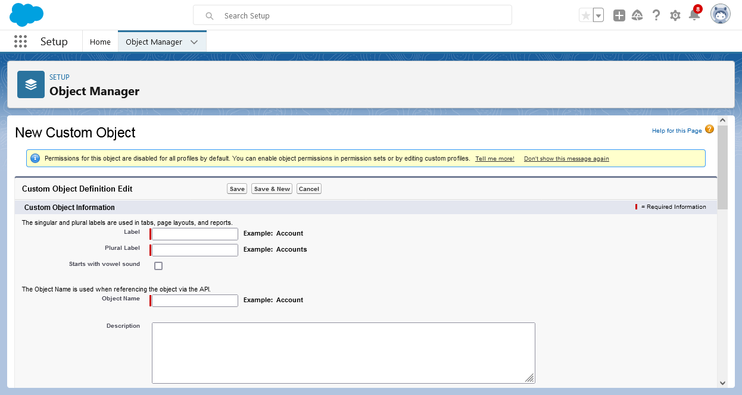

* Click New Custom Object to create above custom objects.
* After finishing the custom objects, click on the Fields and Relationship and create what we require to enter the data for the tracking the internal marks.

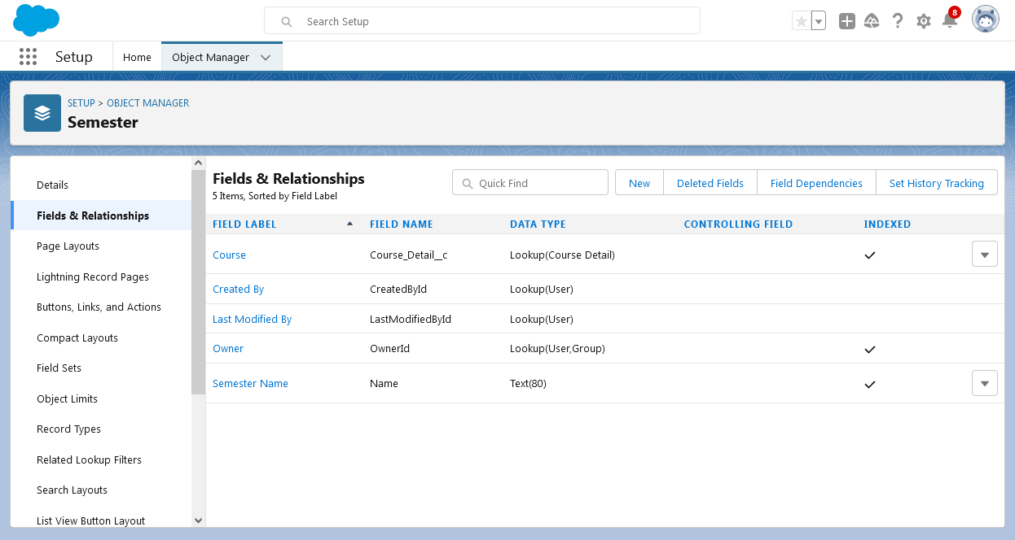

For custom object Semester

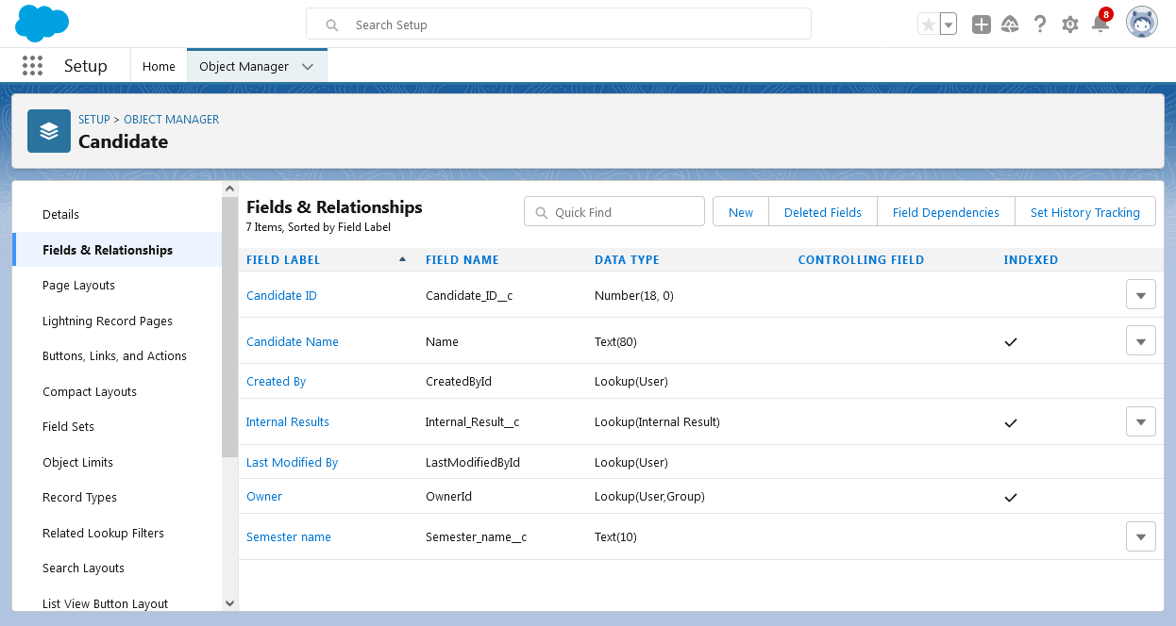

For custom object Candidate

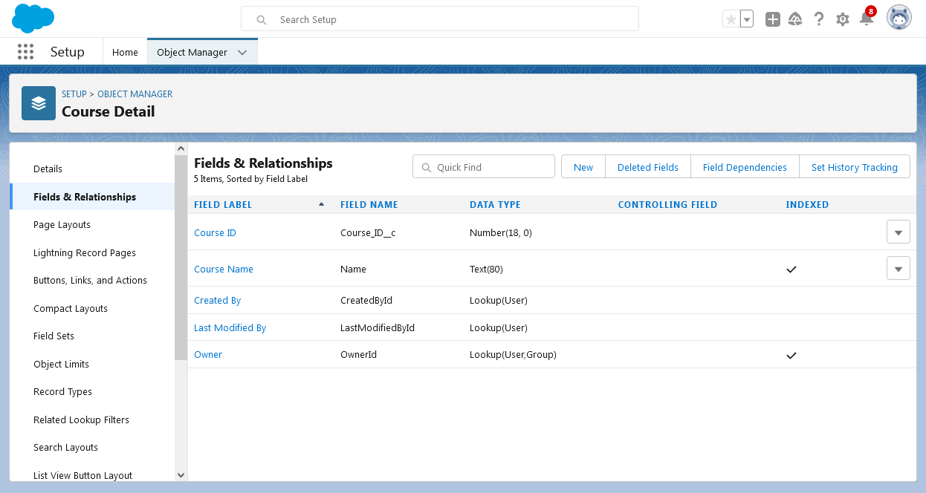

For custom object Course Detail

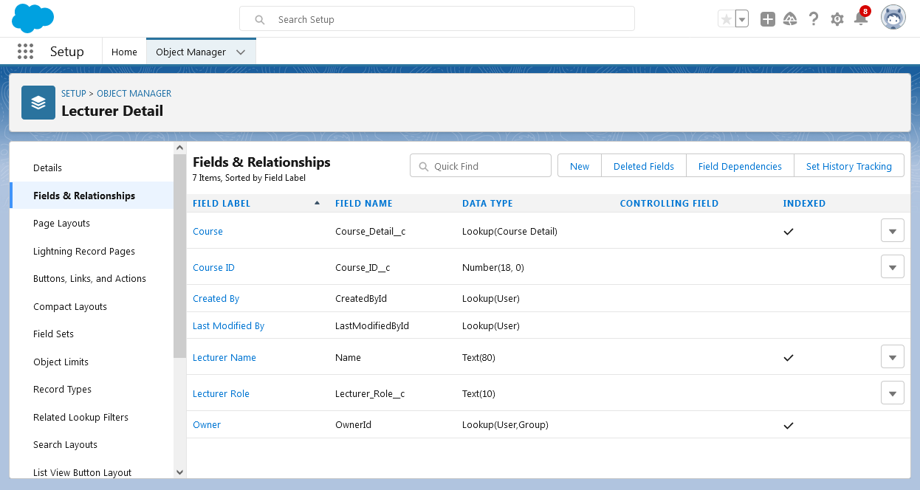

For custom object Lecturer Detail

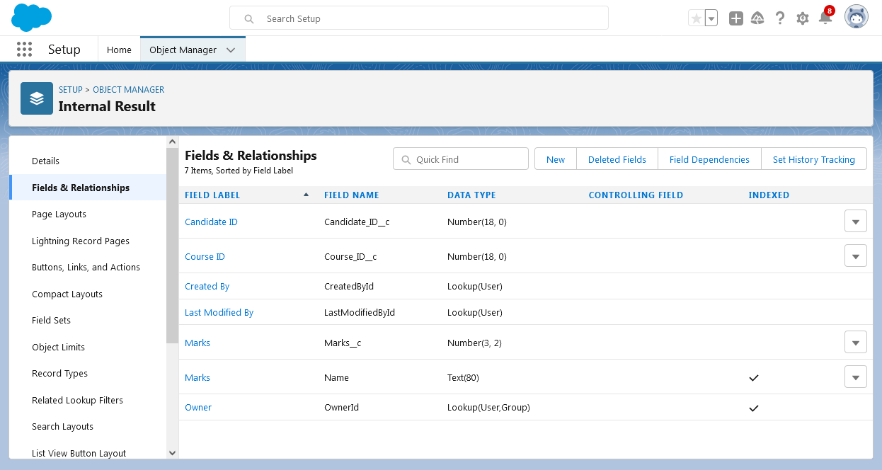

For custom object Internal Result

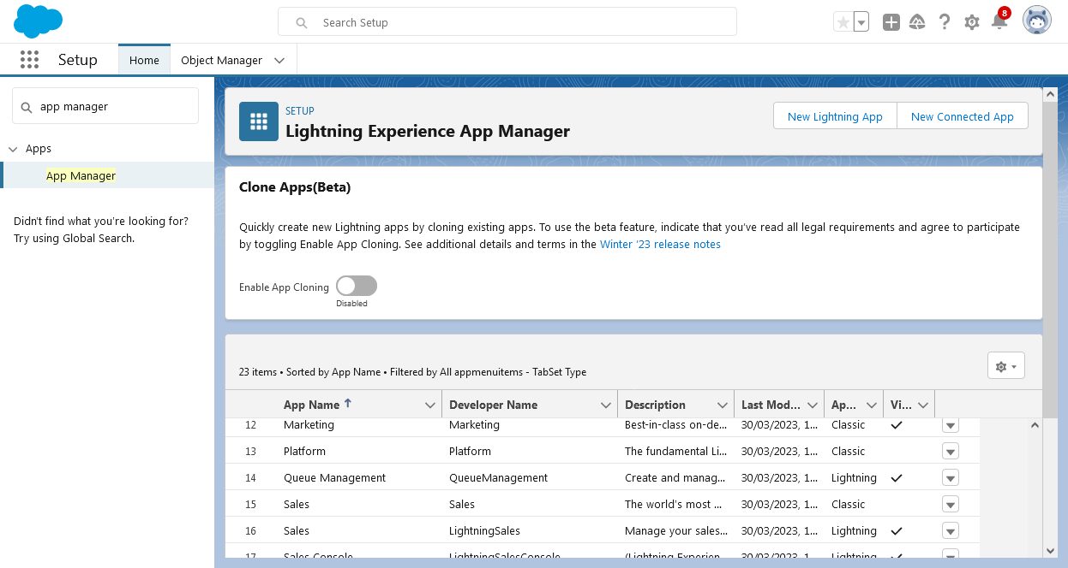

In Quick Find search App Manager and click New lightning app

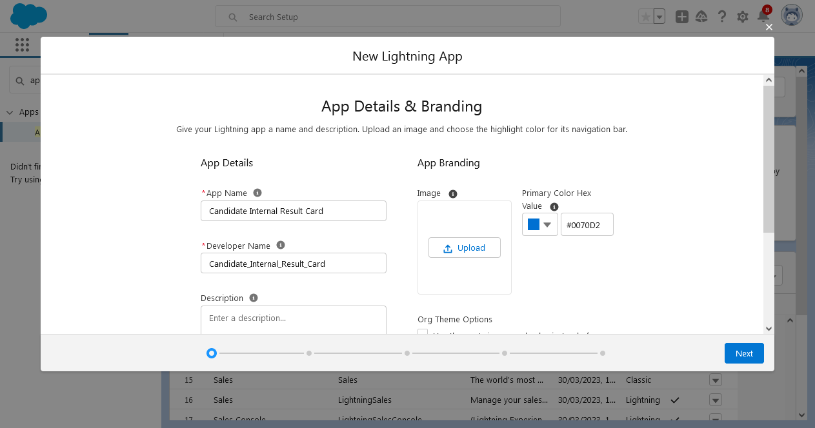

Type App name as Candidate Internal Result Card and click next.

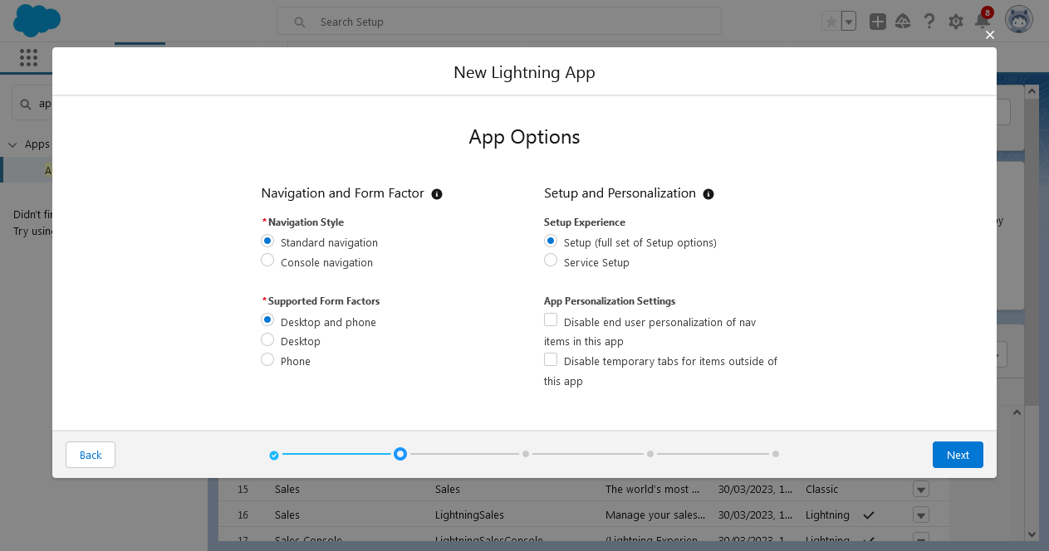

In App options, select next to continue this session.

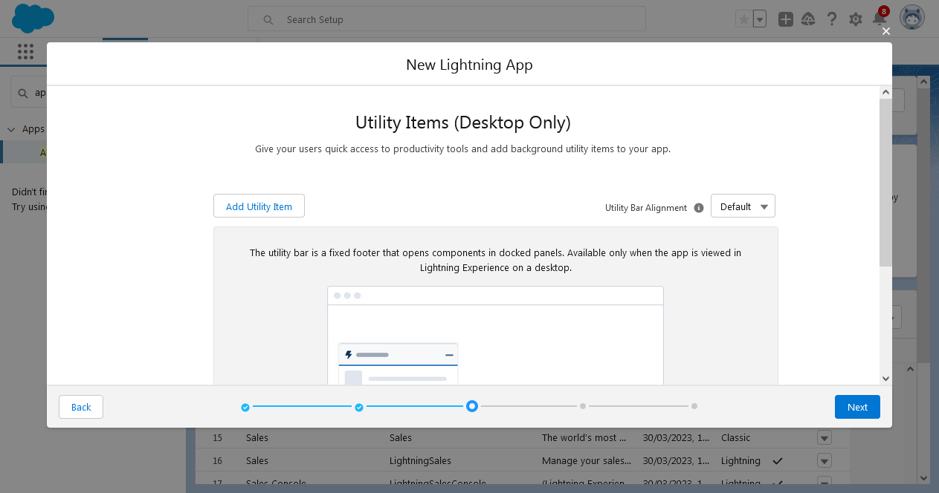

In Utility Items, click next option.

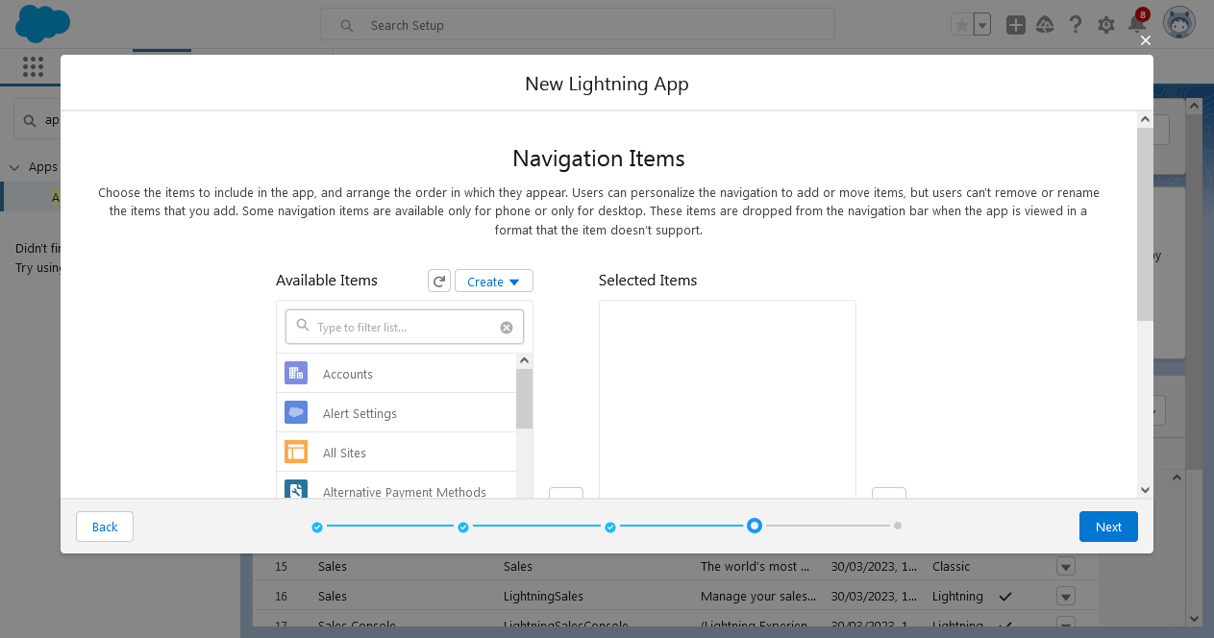In Navigation Items, select the Custom Objects to move to the Selected Objects.

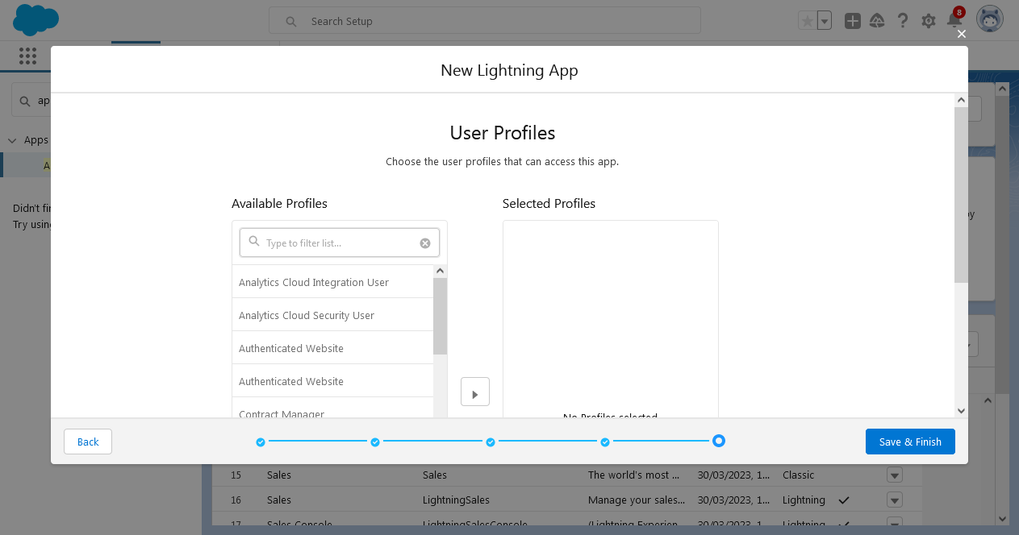

In User profile, select System Administrator and click Save & Finish.

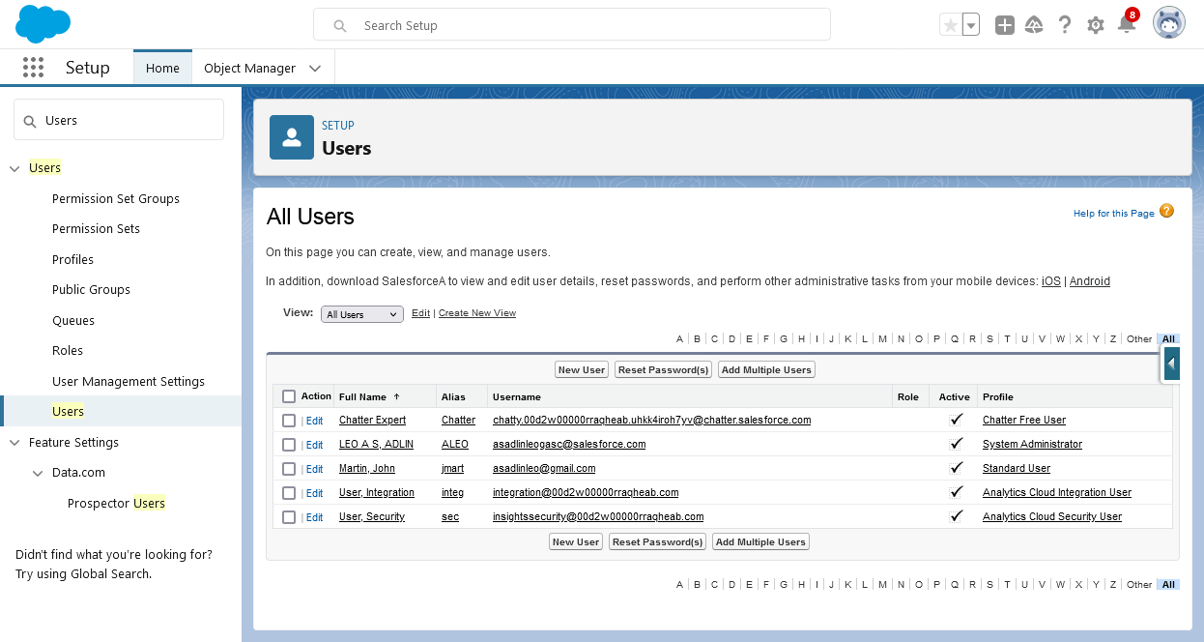

In Quick find, search Users and select it. Then create a New User as a name of the John Martin.

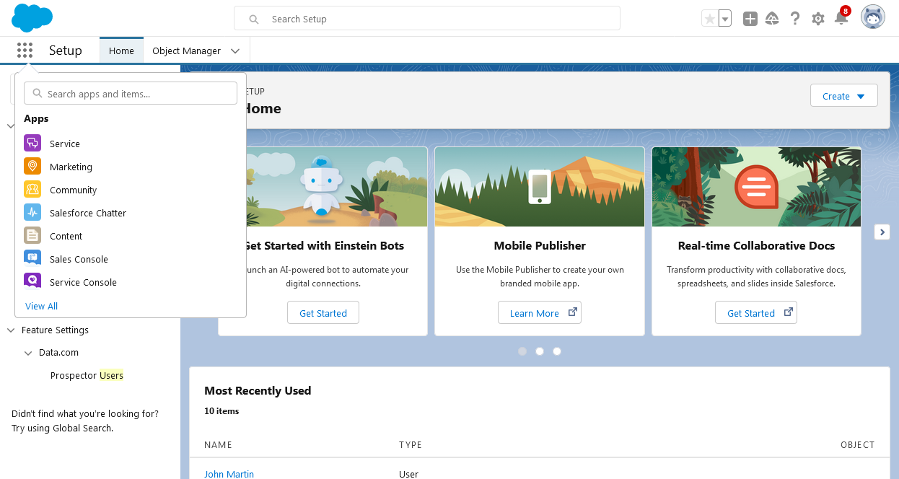

To create a Reports, click on App launcher and type Reports.

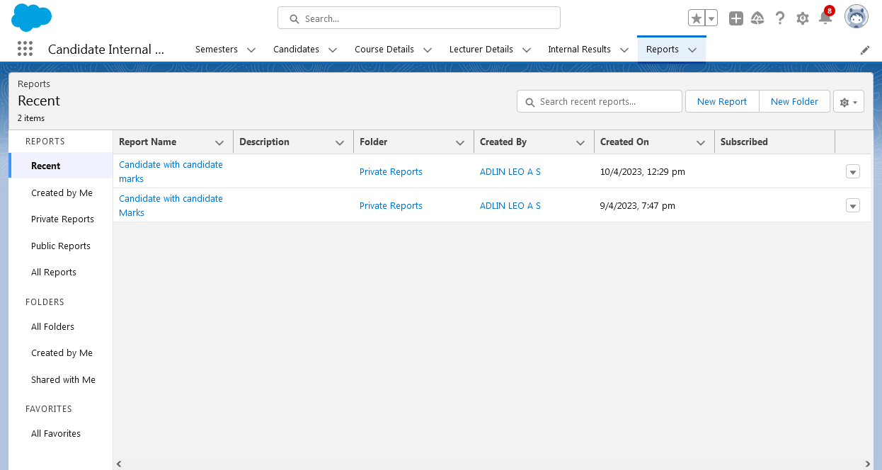

Click on New report, select the report type as Candidate with candidate Marks. Then Save & Run the report.

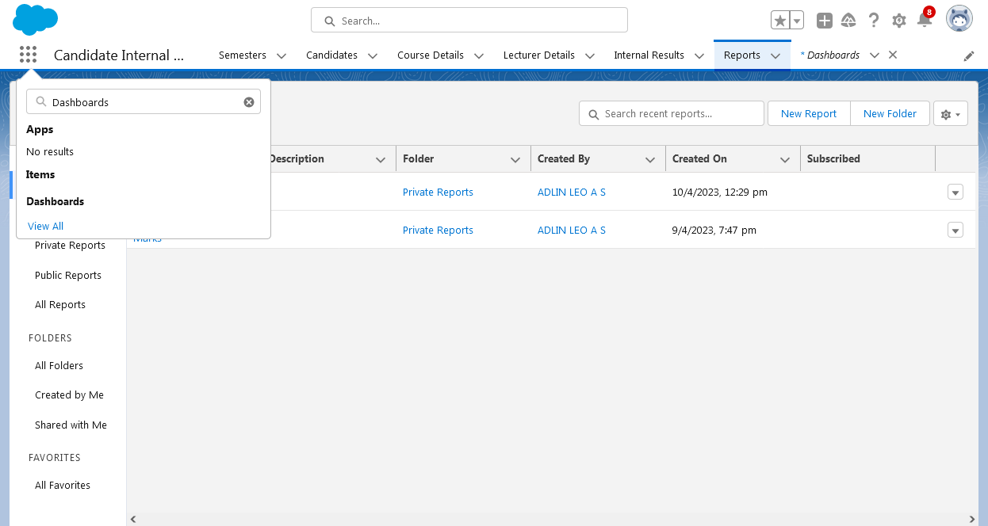

In App Launcher, type Dashboards and create the dashboards as Candidate board.

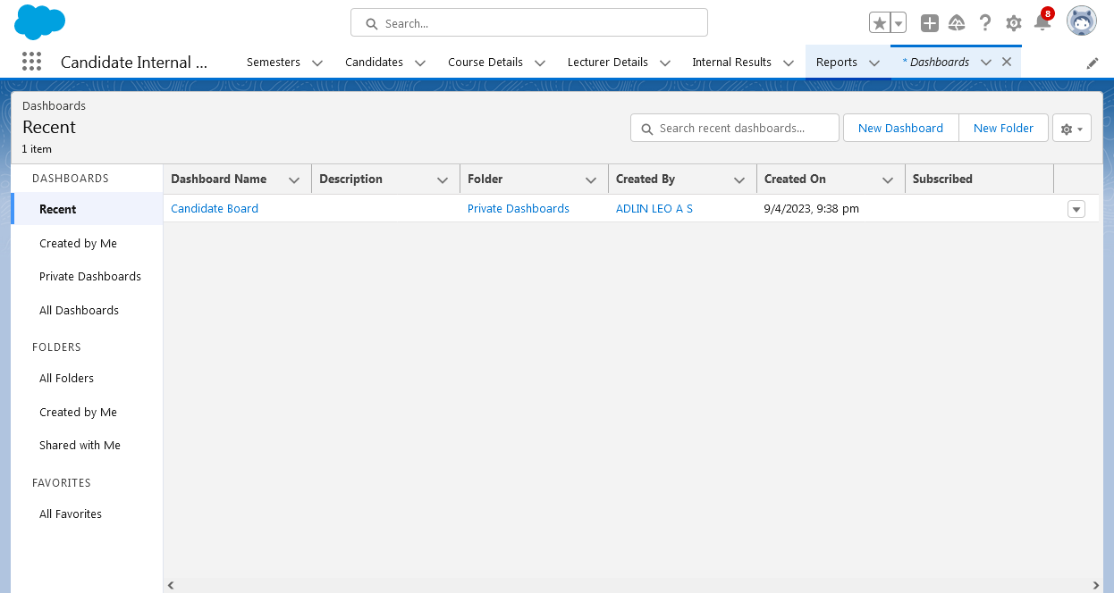

Then create a Vertical chart using the dashboards and data.

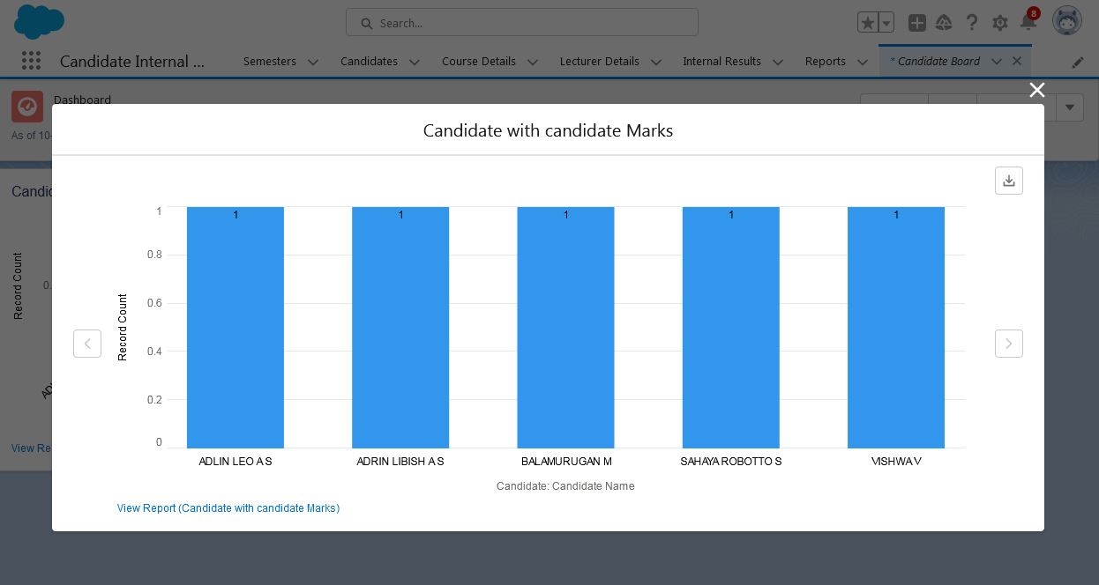

In Dashboards, the vertical chart is drawn.

### 4 Trailhead Profile Public URL

Team Leader -  [https://trailblazer.me/id/adlinleoas](%20%20https://trailblazer.me/id/adlinleoas) ( ADLIN LEO .A.S )

Team Member 1 - <https://trailblazer.me/id/vishv9922> ( VISHWA .V )

Team Member 2 - <https://trailblazer.me/id/balam137> ( BALAMURUGAN.M )

Team Member 3 - <https://trailblazer.me/id/srobotto> ( SAHAYA ROBOTTO .S )

### 5 ADVANTAGES & DISADVANTAGES

### Advantages:

* Easy way to handle.
* High informations are stored.
* Candidate details are stored in a correct manner.
* Everyone can access their personal details.
* The Internal results or Marks entered by a proper verification.
* Wherever the place this application is used.
* It can be used in the Educational related places.
* It can be used in all over the world.

### Disadvantages:

* It is difficult to use other member information.
* If the given detail is wrong or it can be changed by the individual with a proper certificates and mark statements.

### 6 APPLICATIONS

1. School
2. College
3. Office
4. Reasearch centre
5. Lab
6. Institution
7. Library

### 7 CONCULSION

This application is applicable for all the students and candidates. Everyone can use this application. It can be give a new way to handle a Internals results and Marks.

### 8 FUTURE SCOPE

In Future, this type of many applications are programmed and developed for the students and candidates.

There is a chance to produce a advance level of the Internal results tracking using CRM.